Linking hydrodynamic and ecological models in estuaries:
a workshop to discuss recent advances and approaches

September 10-11, 2013

at

U.S. Geological Survey Woods Hole Science Center
Woods Hole, MA

We are convening a workshop to discuss advances in understanding estuarine ecology through coupled hydrodynamic-ecological modeling. While substantial effort has been invested in developing models for establishing TMDLs, there are parallel efforts to develop models for research purposes: looking at connections between hydrodynamics, nutrient loading, ecological function, climate change, etc. with models of varying complexity and implementation.

We are inviting talks that attempt to account for both hydrodynamics and ecology in some fashion, and focus on the advances and shortcomings of the approach. We will group talks into themes, and then spend time after each session discussing the lessons with the speakers and their collaborators.

Some suggested themes:
- Balancing spatial and temporal resolution
- Adding and removing complexity
- Predicting ecosystem shifts under nutrient loading changes
- Predicting ecosystem shifts under climate change
- Determining observational needs to develop and test models
- Linking approaches
- Community model building

If you would like to present a talk, please send a brief paragraph to nganju@usgs.gov describing the work no later than August 19th.
If you would like to attend only, please RSVP by no later than August 26th.
Attendance will be capped at 50 people due to space constraints.

Workshop cost will be limited to cash donations for coffee service and group BBQ (~$30 total).

Workshop coordinators: Neil Ganju (USGS), Brenda Rashleigh (EPA), Mark Brush (VIMS)

http://woodshole.er.usgs.gov/

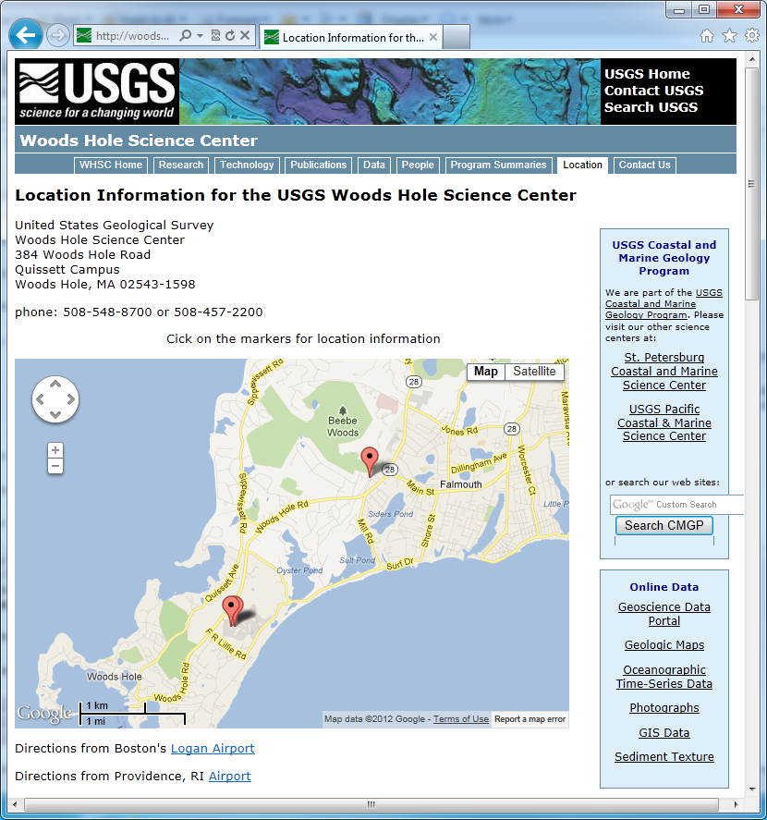

Contact info: Neil Ganju 508-457-2252 (for specifics)

Best airports to arrive through are Logan in Boston, MA, or TF Green in Providence, RI.
There is bus service from those airports to Falmouth, MA via the
Peter Pan Bus service at http://www.peterpanbus.com/ .
Parking available in the Quissett campus lot. We will have stickers for you when you arrive.
Best nearby hotels are:
- http://www.innonthesquare.com/
- http://www.shorewayacresinn.com/index.htm

Tentative Agenda

Tuesday, Sept. 10, 2013
9:00 Introductions and logistics
9:30 First session (three talks, 20-25 min each)
10:45 Break
11:00 Discussion
12:00 Lunch
1:15 Second session (three talks)
2:30 Break
3:00 Third session (three talks)
4:15 Discussion
6:00 BBQ on-site (please bring $10 cash if attending)

Wednesday, Sept. 11, 2013
9:00 First session (four talks)
10:45 Break
11:00 Discussion
12:00 Lunch
1:15 Second session (three talks)
2:30 Break
3:00 Third session (three talks)
4:15 Discussion and conclusion

