- I have compared model with SODA data. As SODA data starts from the depth of 5m, it is considered as the surface value. Model data is interpolated for all SODA depth to compare between model and SODA. Salinity is not a big problem but Temperature (within 50-200 meters’ depth) is the main problem.
- Basin averaged temperature (T) of model is 0.5ºC lower (vertically mean) and hence it is lower in all depth than SODA. Suddenly T is 2-3ºC lower in model within the depth of 55-98m. But the T difference gradually reduces with the increase of the depth after 200m. (higher mixing might solve the problem)
- From the spatial map, I can understand that the distribution pattern is divided into two regions. One is the equatorial region and another is the bay north of 6ºE.
- Model minus Soda in April month:
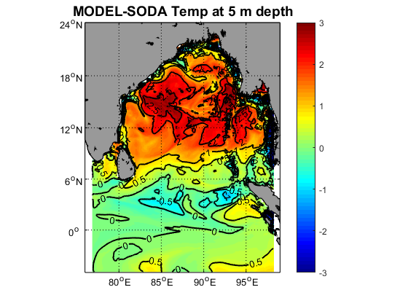

- Model T is always lower than SODA from 5m up to the depth of more than 200m in the equatorial region. (Higher Mixing will solve the problem?? Or Atmospheric forcing is not good??)

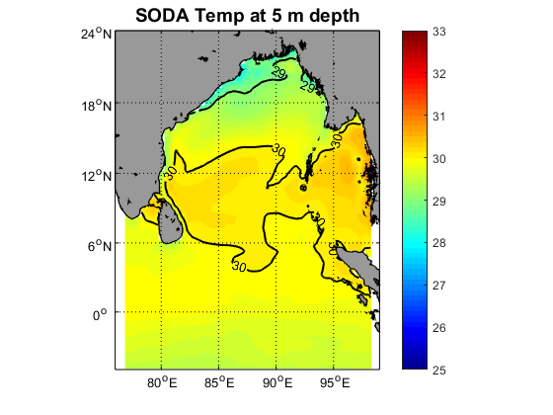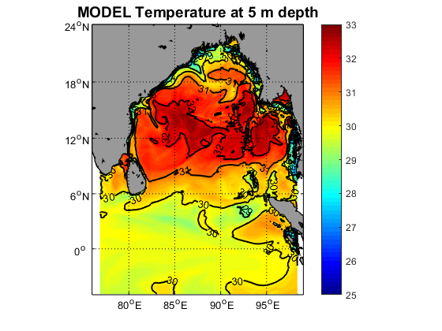

- But in the north bay 5m T is 1-2.5ºC higher than SODA mainly during spring season (Atmospheric forcing seems not good?). With the increase of the depth T difference is reduced. (Mixing is less now??)
- Basin averaged model salinity (S) is 0.1 psu lower (vertically mean) than SODA. 5m S is very low nearby the river mouth but it is similar to SODA at others area. (River salinity is set zero now. Adding climatology salinity of river mouth can solve this problem??)
- Model S is 0.2-0.3 psu higher in the depth of 15-55m. After the depth of 200m model S is similar to SODA. (Higher Mixing will solve the problem??)

- Model and SODA temperature compare:

- Model and SODA Salinity compare:

- Vertical section of temperature compares of May month along south to north direction (90E): Model (first) vs Soda (second):

- Vertical section compares of May month along south to north direction: Model (first) vs Soda (second):

